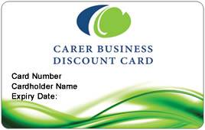

How to get the most out of your

Carer Business Discount Card
Your Carer Business Discount Card gives you access to great savings and services at thousands of participating businesses across the state. Keep your car running smoothly, get a great price on your home insurance, or enjoy a discounted night out.

Start saving
Your card is now ready to use. First, dispose of your old Foster and Kinship Carer Card because this has been discontinued. Sign the signature strip on the back of your new Carer Business Discount Card. Pop it in your wallet and carry it with you whenever you go shopping.
There is no need to renew your card – you will automatically be issued with a new card every four years if you remain an approved foster or kinship carer.

Shop around
Participating businesses will display a sticker in their window or at the point of sale. Even if you do not spot a sticker in your preferred shop, you could still ask whether the business offers discounts to Carer Business Discount Card holders.
Remember to present your card at the time of purchase for goods, or when organising quotes or estimates for services.

Search and save
For your convenience, all business discounts are available through our website so you can find the latest offers in your area at your fingertips. It is also easily available on your smart phone so you can search for local discounts when you are travelling within Queensland.

Pick up a directory
The Business Discount Directory for Seniors and Carers is your guide to the best discounts from businesses in your local area. Drop into your local library, government office or seniors organisation to pick up your copy. A full list of pick points is available on our website or you can order your copy online.
To find out more go to www.qld.gov.au/carerscard
For further enquiries about your card call Card Services on 13QGOV (13 74 68).

